Ward Falkner Competitive Obedience Seminar
Presented by the Winnipeg Area Shetland Sheepdog Association

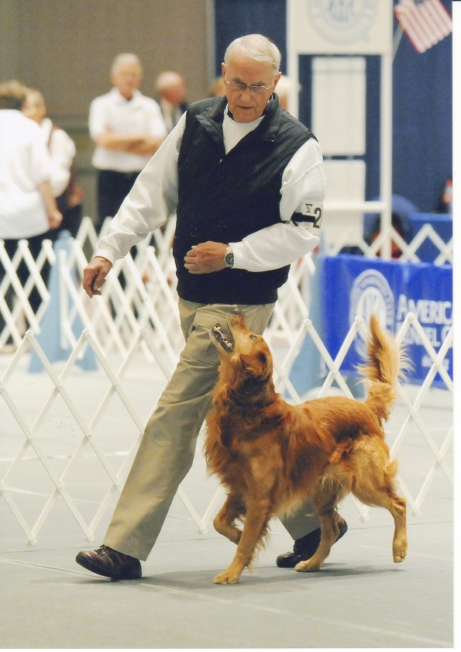
Seminar / Workshop Topics
- How dogs learn – through association, consequences and reinforcement,
- How to apply the learning processes in training for competition obedience
- Using play training to create a positive attitude in your dog
- Getting a “want to” rather than “have to” attitude in your dog
- Heeling, recalls, scent work, signals, and go outs
- Training exercises in all areas of competitive obedience
Ward Falkner and Zoom’s Team Accomplishments
- Over 250 High in Trials!
- 54 perfect 200’s – a record in the history of Canadian obedience trialing
- Established a record for the number of perfect 200’s achieved in a single year at 15
- Placed in Canada’s Top Ten obedience dogs for past 6 years – 2008 as #1, presently ranked #3
- At two years old was the youngest dog in Canada to achieve the GMOTCh title
- High in Trial Golden Retriever Club of Canada National Specialty - 2008, 2009, 2011 with two perfect scores
- Invitee and participant in the AKC/Eukanuba National Invitational – 2008, 2009, 2010, 2011, 2012
- Winner AKC/Eukanuba National Invitational 2011 earning the title of NOC (National Obedience Champion)
- Only obedience team in history to have been ranked #1 in Canada and also win the U.S. National Obedience Invitational, and the only non-American team to have won the NOI
“This is an absolutely amazing team. Insanely accurate, while maintaining SPEED and STYLE!!! Everyone should be striving to attain all three . . . often, the style and speed get lost while pushing for more and more accuracy. Congrats, Ward and Zoom, well deserved." Petra Ford, a fellow competitor, twice NOI Champion and 1st Place Tie in the Crufts World Obedience Championship.

Ward Falkner and NOC, GMOTCH, OTCH.
Spirit’s Zim Zam Zoom OM4 UD6
competing at the AKC/Eukanuba National
Obedience Invitational in 2009
May 12-13, 2012
Pawsh Dog Training Centre
Unit 8- 1580 Taylor Avenue
Winnipeg, Manitoba
Please contact Terry Lambert
terrylambert@shaw.ca
Phone (204) 831-6923
Or visit www.wassa.ca
for more information
$225.00 2-Day Working Spot
$125.00 2-Day Audit Spot
Lunches Included
Limited Reservations

Ward Falkner Competitive Obedience Seminar
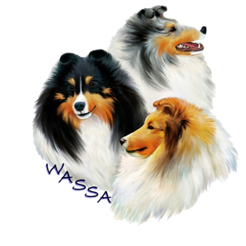
REGISTRATION FORM
2 Day Working Spot Reservation - $225.00
2 Day Audit Reservation - $125.00
May 12-13, 2012
Pawsh Dog Training Centre
Unit 8- 1580 Taylor Avenue
Winnipeg, Manitoba
All well-behaved dogs are welcome for working spots. Dogs must be on leash or crated when not working. Please bring your own crates, leashes, training toys and treats, water etc. Individual problem solving as time allows. Registration includes lunch, coffee/tea and morning and afternoon snacks. Acknowledgements and a receipt will be sent to all registrants including hotel info if required, directions and seminar schedule.

Please make cheques payable to: Winnipeg Area Shetland Sheepdog Association
Mail to:
Terry Lambert
139 Rodney Street
Headingley, Manitoba R4J 1A6
We also accept paypal for your convenience. Please contact Terry Lambert, below, if you
wish to pay through paypal, and instructions will be provided at that time. Please note all reservations are final. We are unable to provide a refund unless there is someone on our waiting list to take your spot.

Please also complete the attached waiver and submit this along with your registration.
For more information, please contact Terry Lambert (204) 831-6923 terrylambert@shaw.ca
or visit www.wassa.ca

NAME: _________________________________________________________________
ADDRESS: _______________________________________________________________
CITY, POSTAL CODE: _______________________________________________________
TELEPHONE: _______________ E-MAIL: ______________________________________
NUMBER OF DOGS (Maximum 2) ________
NAME OF DOGS(s) and BREED(s) _____________________________________________
Please note only dogs registered for the seminar will be allowed in the building.

Ward Falkner Competitive Obedience Seminar
WAIVER

Reservations and registration for this seminar cannot be accepted unless the following waiver is signed and dated:

In consideration of the acceptance of my registration the holding of this event, I/We agree to hold the Winnipeg Area Shetland Sheepdog Association, including its members, officers, and directors, presenter of the seminar, owner of the premises upon which the event is being held and their employees, harmless from any claims for loss or injury which may be alleged to have been caused directly or indirectly to any persons or thing by the act of this dog while in or upon the event premises or grounds or near entrances thereto, and I/We personally assume all responsibility and liability for any such claim.
I/We further agree to hold the aforementioned parties harmless from claims of this dog by disappearance, theft, death or otherwise from any damage or injury to the dog, whether such loss, disappearance, theft, death or otherwise be caused or alleged to be caused by negligence of the parties aforementioned, or by negligence of any person, or any cause or causes.
I/We hereby assume the sole responsibility for and agree to indemnify and save the aforementioned parties harmless from any and all loss and expense (including legal fees) by reason of the liability imposed by law upon any of the aforementioned parties for damage caused by bodily injuries, including death at any time resulting thereof, sustained by any person or persons, including myself/ourselves or on account of damage to property, arising out of or in consequence of my/our participation in this event, however such injuries, death, or damage to property may be caused and whatever or not the same may have been alleged to have been caused by negligence of the aforementioned parties or any of their employees or agents or any other persons.

Date: _______________

Signed: ________________________________________

